COVID-19 Outdoor Prevention Social Media
The Trail Etiquette (image 1) graphic is very similar to the physical signage you may already have up for been posting no social media. The only difference is it no longer has a website link on the bottom, and the COVID-19 label was taken off the top for formatting/sizing purposes. The new image is called Stay Healthy at the Park (image 2), this features some new images on focuses on both social distancing and some hygiene recommendations. You can right click on the images below and save them to your computer to use them in social media posts later. Please feel free to add your logo to either of these before posting them on social media. If you do not have the capability or prefer not to, that’s ok too!
Image 1: Trail Etiquette
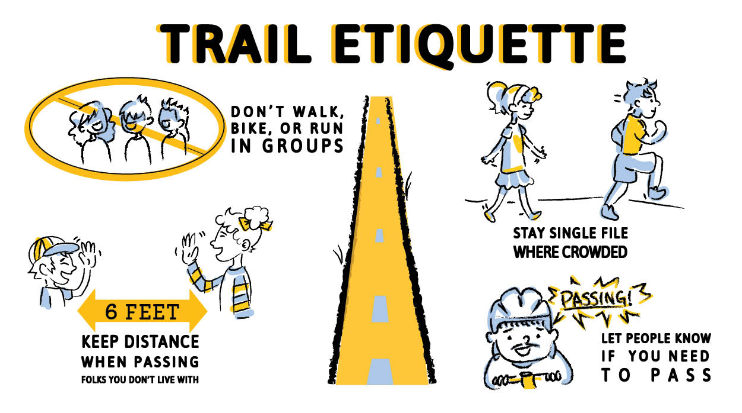
Example Text for Posts:
TWITTER
Heading to one of our local paths or trails this weekend? Physical distancing is still important! Here are some simple tips for giving people space so everyone can #stayhealthyoutside
Planning on hitting a local trail sometime soon? Physical distancing is still important! Here are some simple tips for giving people space so everyone can #stayhealthyoutside

FACEBOOK
Enjoying time outside is important to both physical and mental health, but we need to make sure everyone can #stayhealthyoutside. Luckily there are easy ways to give people space!
Local paths and trails calling your name? Go use them! Remember though, it’s still important to give people space and make sure everyone can #stayhealthyoutside

Image 2: Stay Healthy at the Park
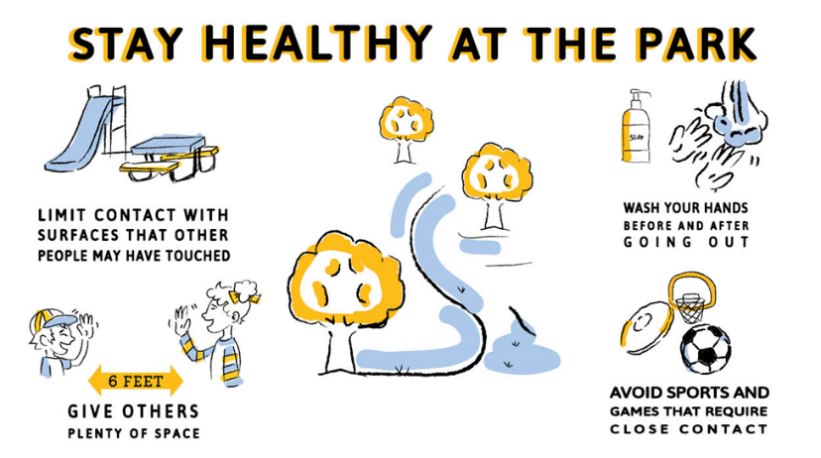

Ideas for posts:
TWITTER
Heading to one of our local parks this weekend? Good hygiene is still important. Here are some simple tips to #stayhealthyoutside
Good hygiene is important EVERYWHERE you go. Follow these simple tips to #stayhealthyoutside

FACEBOOK
Heading to one of our local parks this weekend? Good hygiene is still important. Here are some simple tips you can use to #stayhealthyoutside
Good hygiene is important EVERYWHERE you go. Follow these simple tips to #stayhealthyoutside

Note: Don’t feel limited to these exact posts, get creative and make posts that will be appreciated by your unique audience! The general idea with our example posts are that we want to have folks recognize that physical distancing is still important and hygiene is still important (even outside) and that following the tips in the graphic is simple and easy. We also put an emphasis on the fact that social distancing and hygiene are good for EVERYONE.
We do ask though that you include the #stayhealthyoutside hashtag in whatever you decide to post. This hashtag is going to help us track how many people are using and sharing the posts on Twitter and Facebook.

Tips for Maximizing Facebook and Twitter Reach
The trick with social media is your initial post will only go to the group of people who ‘follow’ your org or agency page. For some this may mean a lot of initial reach, for others this may mean very little initial reach. To expand your message reach you can:
-Ask colleagues at other city or county offices (e.g. libraries, main city gov accounts) to share your post!
-Post initially on your org/agency account and then share that initial post on your personal account and encourage your personal network to share
-Ask family and friends to share your initial org/agency post
All of these ideas help to expand the number of people who see and may further share your post.

Other Social Media
If you have additional social media accounts for your org/agency (e.g. Instagram, TikTok, Snapchat, or others there are some fun ways to spread prevention messaged and promote prevention behaviors! Videos may be an especially good way to get some engagement and for the most part all you need is the camera and microphone on your smartphone!
Some ideas:
- Post pictures or videos of your staff following social distance or hygiene recommendations! Your staff are often people that community members look up to and so can use them to model social distancing and hygiene behaviors! You can still use #stayhealthyoutside even on posts like these. For posts like these it is important that you are following your own advice though, so make sure you’re at 6 ft of distance or wearing a face covering!
Examples:
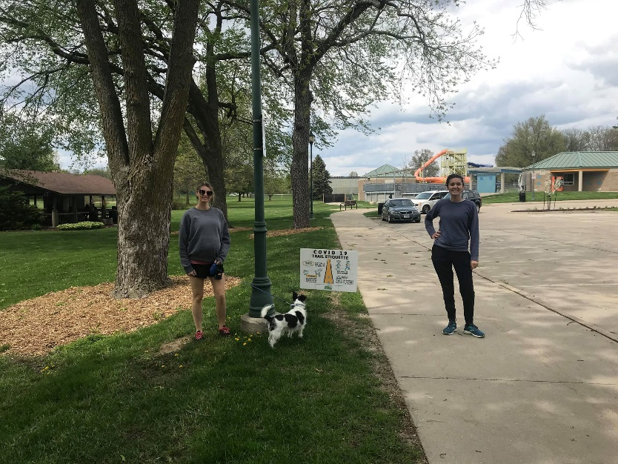
TWEET TEXT: Our staff know that giving other people at least 6 feet of space is important for helping everyone #stayhealthyoutside

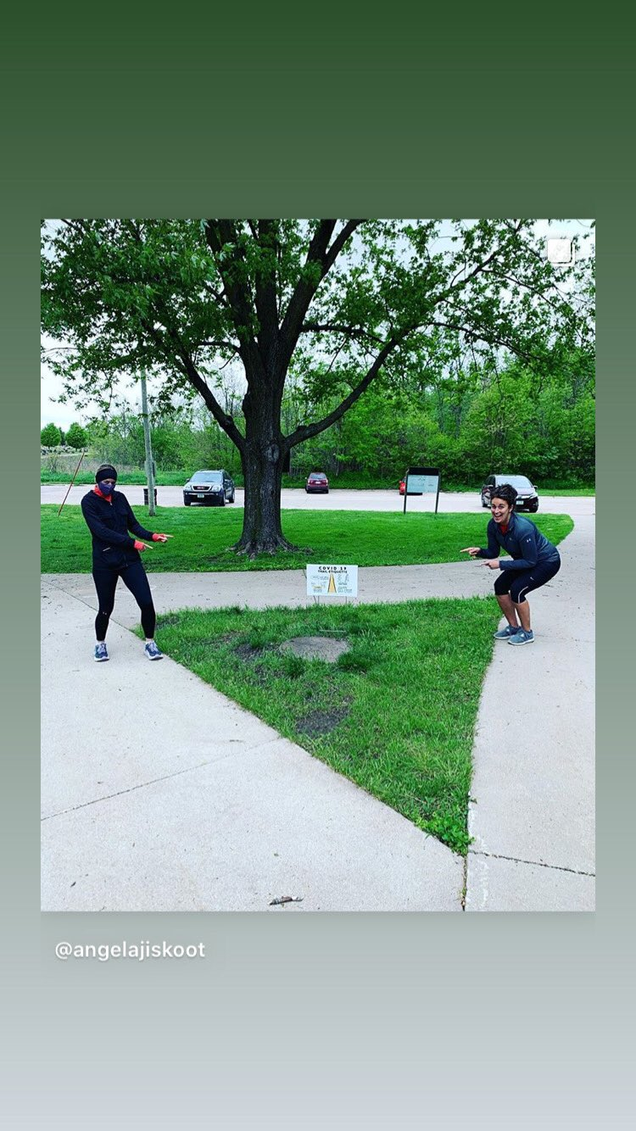
TWEET TEXT: Saw these cute reminders at Arbor Lake in Grinnell! #stayhealthyoutside

- You can also share additional resources from the CDC around the social distancing and hygiene recommendations
EXAMPLES
How to WEAR FACE COVERINGS: https://www.cdc.gov/coronavirus/2019-ncov/prevent-getting-sick/diy-cloth-face-coverings.html
https://www.cdc.gov/coronavirus/2019-ncov/downloads/cloth-face-coverings-information.pdf

HANDWASHING- https://www.cdc.gov/handwashing/materials.html
These may be especially important once Rec centers open back up! There are posters and other fun materials you can post in the rec center but also videos and such to post on your social media!

SOCIAL DISTANCING- https://www.cdc.gov/coronavirus/2019-ncov/prevent-getting-sick/social-distancing.html

