January 2023

Dear Cancer Control Partners:

The Iowa Cancer Consortium is dedicated to bringing you, our cancer control stakeholders, timely and credible cancer information to share with your community.

In the pages to follow, you will find a series of Facebook and Twitter messages, curated from trusted organizations and partners including the Centers for Disease Control and Prevention (CDC), The United States Environmental Protection Agency (EPA), The National Environmental Education Foundation (NEEF), Iowa Department of Health and Human Services (Iowa HHS), The American Cancer Society (ACS), and many more!

A new addition to the messages produced by the Iowa Cancer Consortium are Canva Templates. Any image with the Consortium’s logo can be opened and downloaded from Canva. Feel free to add your organizations logo in space next to the Consortium’s logo.

Our hope is that you will find these messages useful as we work to reduce the burden of cancer in Iowa … together!

If you have specific questions or would like to learn more, please contact Abby Batterson, Communications Coordinator, batterson@canceriowa.org.

Sincerely,

The Iowa Cancer Consortium
Web | Facebook | Twitter | Instagram | YouTube | LinkedIn

This Month’s Featured Content: Ctrl + Click to Follow Link
- Cervical Cancer Awareness Month
- National Radon Action Month

Cervical Cancer Awareness Month
For additional resources, visit: American Cancer Society, Care for Yourself Program (Iowa HHS), and the CDC.
Facebook | Twitter | Suggested Image  (Click image to open and save)
January is Cervical Cancer Awareness Month. Cervical cancer screenings are now recommended for people with a cervix who are 25 or older. To learn more, visit: https://bit.ly/3Yx6qZQ | January is #cervicalcancer awareness month. Cervical cancer screenings are now recommended for people with a cervix who are 25 or older. To learn more, visit: https://bit.ly/3Yx6qZQ | 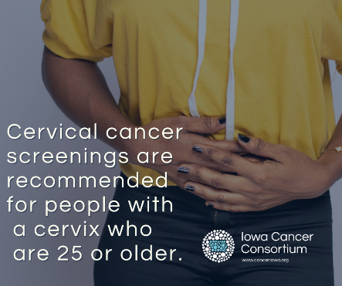
Did you know that you may qualify for free cancer screenings? Iowans aged 21-64 with a monthly take-home pay of $2,832 or less (adding $983 for each additional household member) may qualify. Learn more:  https://idph.iowa.gov/cfy | Do you qualify for free #cancer screenings in Iowa? Click the link below to find out: https://idph.iowa.gov/cfy | Link has image.
Iowa Cancer Consortium member Emily Hoffman of Cervivor wrote about her experience with cervical cancer: “I went to my doctor every year for my annual well-woman exam and the results of my Pap tests always came back normal. But somehow, in the span of only one year, a 4 cm tumor had grown on my cervix. In one year, I went from having a normal Pap test result to having cancer. What a difference one year can make.”  Read more of Emily’s story and learn important information about cervical cancer prevention and screening: https://bit.ly/3hBCN9b | Emily Hoffman of Cervivor speaks about her #cervicalcancer diagnosis at age 30 and what you can do to protect yourself: https://bit.ly/3hBCN9b | Link has image.
Cervical Cancers are caused by the Human Papillomavirus, also known as HPV. There are many types of HPV, and some are known to cause changes to a person's cervix that can lead to cervical cancer. https://idph.iowa.gov/cfy/cervical-cancer | Cervical cancers are caused by the Human Papillomavirus, also known as HPV. There are many types of HPV, and some are known to cause changes to a person's cervix that can lead to cervical cancer. https://idph.iowa.gov/cfy/cervical-cancer
The result of an HPV test, along with Pap test results, will determine your risk factor for developing cervical cancer. If you are positive for HPV, talk to your gynecologist about next steps. https://bit.ly/3G4LpyM | If you are positive for HPV, talk to your gynecologist about next steps to prevent and screen for cervical cancer. https://bit.ly/3G4LpyM | 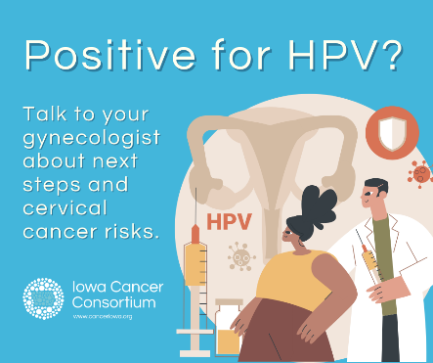
The HPV vaccine protects against multiple types of cancer. Cervical cancer, which is linked to HPV, kills 4,000 people in the United States each year. If you need to catch up on HPV vaccines, this blog is a great place to start.  https://bit.ly/3PAFvZ8 | The #HPV vaccine protects against multiple types of cancer. #Cervicalcancer, which is linked to HPV, kills 4,000 people in the United States each year. If you need to catch up on HPV vaccines, this blog is a great place to start.  https://bit.ly/3PAFvZ8 | Link has image
If your teen isn’t vaccinated against HPV yet, talk to your doctor about getting a vaccine appointment set up ASAP. To learn about the HPV vaccine, click here: https://www.cdc.gov/hpv/parents/vaccinesafety.html | If your teen isn’t vaccinated against #HPV yet, talk to your doctor about getting a vaccine appointment set up ASAP. To learn about the HPV vaccine, click here: https://www.cdc.gov/hpv/parents/vaccinesafety.html | 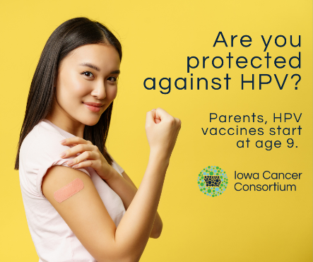
The HPV vaccine is safe and effective, with over 15 years of monitoring and research. The vaccination allows for long lasting protection against diseases like cervical cancer. https://www.cdc.gov/vaccinesafety/vaccines/hpv-vaccine.html | The #HPVvaccine is safe and effective, with over 15 years of monitoring and research. The vaccination allows for long lasting protection against diseases like cervical cancer. https://www.cdc.gov/vaccinesafety/vaccines/hpv-vaccine.html | 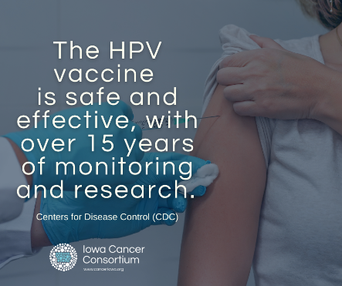
Concerned about the cost of #cervicalcancer screenings? Call 1-866-339-7909 to see if you qualify for free screenings or visit https://idph.iowa.gov/cfy | Concerned about the cost of #cervicalcancer screenings? Call 1-866-339-7909 to see if you qualify for free screenings or visit https://idph.iowa.gov/cfy | Link has image.
Did you know that you can prevent contracting most types of HPV through the HPV vaccination series? Learn more from Iowa HHS: https://idph.iowa.gov/immtb/immunization/hpv | The #HPVvaccine is a form of cancer prevention. Learn more from Iowa HHS: https://idph.iowa.gov/immtb/immunization/hpv | Link has image.

National Radon Action Month
For additional resources, visit: American Lung Association, CDC, EPA, and Iowa HHS.
Facebook | Twitter | Suggested Image  (Click image to open and save)
While you can’t see, smell or taste radon, it could be present in your home at cancer-causing levels. Learn how to test your home: https://bit.ly/3I4fgZz | While you can’t see, smell or taste #radon, it could be present in your home at cancer-causing levels. Learn how to test your home:  https://bit.ly/3I4fgZz | 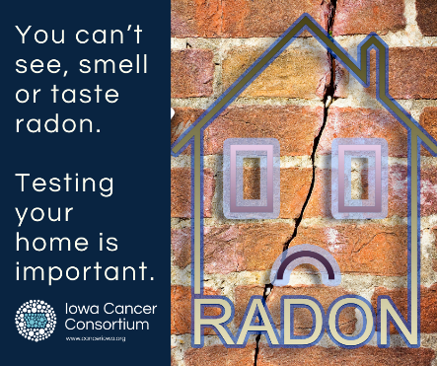
The Gail Orcutt Radon School Safety Act was signed into law by Governor Reynolds on May 24, 2022. This law requires all Iowa public schools to test their attendance centers for radon and, if necessary, mitigate radon in their schools by 2027. https://bit.ly/3HZ3CyL | The Gail Orcutt Radon School Safety Act requires all Iowa public schools to test their attendance centers for radon and, if necessary, mitigate radon in their schools. https://bit.ly/3HZ3CyL | Link has image.
January is National Radon Action Month. Here are tips on how you can take action and protect yourself from radon exposure: https://bit.ly/3jimjmI | January is National #RadonActionMonth. Here are tips on how you can take action and protect yourself from #radon exposure: https://bit.ly/3jimjmI | 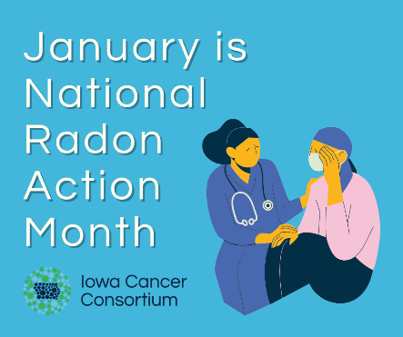
"It's the only cancer diagnosis that you have to defend. Somebody would say to me, 'I didn't know you smoked.' I never smoked."- Maria Steele, radon cancer patient. https://bit.ly/3WI7OXS | "It's the only cancer diagnosis that you have to defend. Somebody would say to me, 'I didn't know you smoked.' I never smoked."- Maria Steele, #radon cancer patient. https://bit.ly/3WI7OXS | Link has video
Did you know that radon is the second leading cause of lung cancer after cigarette smoking? Having your home tested is easy and the only effective way to determine if you and your family are at risk. Learn more about radon from the @CDC here:  https://bit.ly/3PEz2ME | #Radon is the second leading cause of lung cancer in the US. Having your home tested is easy and the only effective way to determine if you and your family are at risk. https://bit.ly/3PEz2ME | 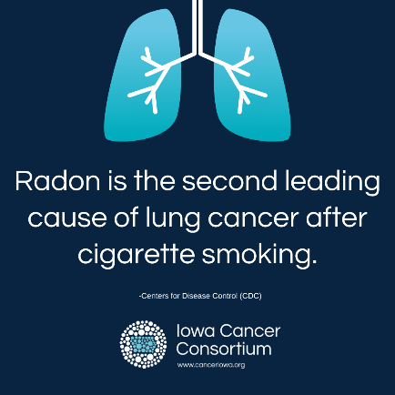
Maria Steele, retired ARNP at Iowa Digestive Disease Center, speaks with Dr. Nish regarding Lung Cancer, risk factors for people who have never smoked and Radon awareness. https://spoti.fi/3WklzMQ | Maria Steele, retired ARNP at Iowa Digestive Disease Center, speaks with Dr. Nish regarding #LungCancer, risk factors for people who have never #smoked and #Radon awareness. https://spoti.fi/3WklzMQ | Link has image.
Scientists estimate 20,000 lung cancer deaths in the US each year are attributed to high levels of radon at home. If you use tobacco products and are also exposed to radon, your risk for developing lung cancer is increased 10x. Learn more about radon testing and mitigation from Iowa HHS: https://idph.iowa.gov/radon  If you’re ready to quit tobacco use, call Quitline Iowa at 1-900-QUIT-NOW or visit https://quitlineiowa.org/ | Did you know that people who use tobacco and are exposed to high levels of #radon have a 10x higher risk of lung cancer? Iowa HHS has resources for radon testing and mitigation: https://idph.iowa.gov/radon as well as tobacco cessation: https://quitlineiowa.org/ | 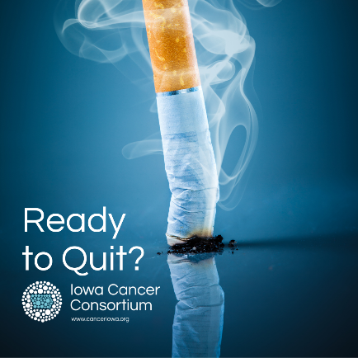
Iowans discuss a decade of grassroots advocacy about the harms of radon and the recent passage of the Gail Orcutt School Radon Safety Act, requiring radon testing to be completed in all Iowa public schools by 2027 and repeated at least once every 5 years. The law also requires all new school construction to incorporate radon-resistant construction techniques.  https://www.facebook.com/IowaCancerConsortium/videos/2399800133509144 | Cancer is a complex and costly disease and addressing it is difficult to do alone. The @Iowa Cancer Consortium helps #Iowans develop partnerships, find funding and build skills and knowledge to reduce the burden of #cancer.  @ACSCANIowa  @MercyOne_Iowa https://www.youtube.com/watch?v=WurAimV672U | YouTube video link
When people buy homes, they often have radon testing. When people rent homes, this often doesn’t happen. Because Iowa has the highest #radon levels of any state, this is a major health concern. https://bit.ly/3N15g3o | When people buy homes, they often have #radon testing. When people rent homes, this often doesn’t happen. Because Iowa has the highest radon levels of any state, this is a major health concern. https://bit.ly/3N15g3o | Link has image.
Have you ever tested your home for radon? To order low-cost radon testing kits, call 1-800-383-5992. For other questions or concerns, check out these resources below: https://idph.iowa.gov/radon | Have you tested your house for #radon? To order low-cost radon testing kits, call 1-800-383-5992. For other questions or concerns, check out these resources below: https://idph.iowa.gov/radon
You’ve just discovered you have elevated levels of radon in your home, now what? The EPA suggests doing a second at-home test to confirm the initial findings. Click here for more information from @UIHC: https://uihc.org/health-topics/radon-cancer-causing-gas | You’ve just discovered you have elevated levels of #radon in your home, now what? The @EPA suggests doing a second at-home test to confirm the initial findings. https://uihc.org/health-topics/radon-cancer-causing-gas | Video Link
Iowa homes have the highest average radon levels in the country. To learn more about how to prevent radon in your home, check these facts below: https://bit.ly/3jCwwL0 | #Iowa homes have the highest average #radon levels in the country. To learn more about how to prevent radon in your home, check these facts below: https://bit.ly/3jCwwL0 | 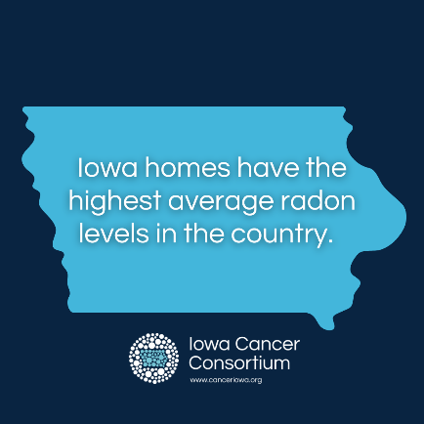
“My husband first set up the kit, followed the instructions and then sent it off. The results came back at over 15 pCi/L (picocurries per liter). The EPA recommends homes be mitigated if the radon level is 4 pCi/L or more.” - Emily Hodgin  Read more of Emily’s story on learning about radon in her home and steps she took. https://canceriowa.org/radon-action-month/ | Read Emily’s story about learning of #radon in her home and the steps she took. https://canceriowa.org/radon-action-month/ | Link has image.
Health care providers, do you ask your patients if they are testing their homes for radon? It could save their lives. Access resources here: https://canceriowa.org/breathing-easier/ | Health care #providers, do you ask your patients if they are testing their homes for #radon? It could save their lives. https://canceriowa.org/breathing-easier/ | Link has image.

